**The Rise of Contactless Payments After COVID 19**

As the Coronavirus disease spread across the globe in early 2020, one of the channels identified as a potential carrier of the disease was currency notes. This has led to a slow decline in the use of cash transactions and cleared the way for the rise in contactless payments. Cash has always been the king in the financial market industry, and specifically in the self-service market. But with recent innovations in contactless payments and its increased consumer adoption, the world is slowly moving towards the era where self-service machines will take contact payments only. This change was already expected to decline steadily in the future but the sudden occurrence of Covid-19 served as a catalyst in accelerating the process.

**How the Covid-19 Pandemic Resulted in Rise of Contactless Payments?**

As a part of personal safety and standard procedures for staying safe from the coronavirus disease during the pandemic and to prevent or slow down the transmission of the virus, more users than ever used contactless payments after lockdown. Even with a decline in the virus cases worldwide as of now, this behaviour is now believed to be firmly established among the consumers in the last few months. For people who have experienced the convenience of contactless payments, it is unlikely that they will return to cash transactions.

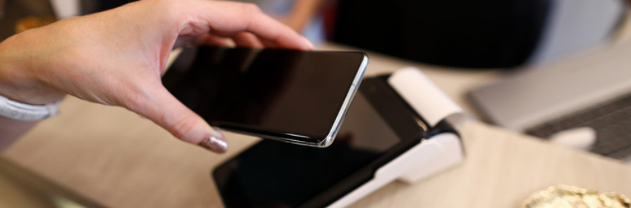

In some countries, the authorities further aided this change by increasing the payment limits in contactless transactions to encourage consumers to [prefer contactless payments over cash transactions](http://www.cardzgroup.com/ContactLessSmartCard.html). This has also given people more choice to opt for convenience and speed to purchase goods with their contactless cards, thus helping to quickly cut queues at checkout counters.

PayMaya, a leader in contactless payments in Philippines, swiftly adopted to this change and introduced virtual credit cards for customers to make contactless payments online, at retail outlets or banks. Another E-wallet company called GCash adapted their products quickly to help support the people during lockdown. As a result, there was a surge in the downloads of the GCash app after the lockdown began and a country where cash transactions were the dominant payment method is now shifting towards the use of contactless technology.

**A Background of Contactless Payments**

So what exactly is a contactless payment? It’s a way to pay for a good or service without the need to physically swipe your card into a machine or passing it on to another person. If you have ever seen a customer tap their phone at a checkout counter to pay for something, you have witnessed the contactless technology in action. Now that the customers want more convenience and assurance from bank tellers or shopkeepers to stay at a physical distance, brick-and-mortar stores are also adapting to the tap-and-pay system.

**How Does Contactless Payment Work?**

Contactless payments typically work by using Radio Frequency Identification (RFID) technology, which is based upon electromagnetic fields. It uses memory chips to store data, or in other words “tags”, alongwith RFID readers to decode the message. By this mechanism, objects in physical proximity can communicate with each other. It is vastly deployed in everyday tasks such as toll collecting, inventory management and parcel tracking.

Contactless payment works by using the Near Field Communication, a latest technology that falls under the umbrella of RFID. RFID works even at larger distances, but NFC only functions when the two objects have a very small distance between them. This is important because it reduces the danger of accidentally carrying out a transaction for someone else as you pass across them. A cardholder can check if their card has NFC capability by checking the indicator for contactless payments, which is a WiFi sign turned sideways.

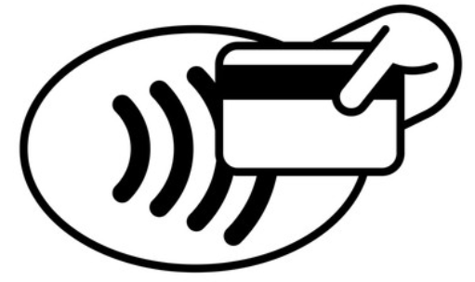

**Transactions in The Post Covid-19 World**

In a survey conducted recently by Mastercard which focused on coronavirus implications, about 82% of respondents across the globe viewed contactless payments as a cleaner alternative to pay and 74% claimed that they will continue to pay through contactless payments even after the pandemic is over. The survey also indicated that there was a 60% decline in ATM transactions since the beginning of the pandemic. According to it, many customers fear handling cash due to virus concerns and even many retail outlets are encouraging this trend by offering only card transactions.

**Why go Contactless?**

This shift in transaction trends will have its implications in the self-service market as the cash-only machines will become unusable by a large number of populations. However, contactless payments not only benefit customers but are also profitable for because machines with contactless payments have more sales and growth in profitability.

NFC payments are generally considered to be secure and effective at reducing fraud. Even after Covid 19, contactless payments would still be convenient for banks, retailers and customers to carry out swift, seamless and socially distant transactional payments. Once these systems are set up, they require very little maintenance. However, their may be some downsides to this, such as outdated systems that will need upgradation, customers who do not have access to smart devices and transaction amount limitations.

**Final thoughts…**

If contactless payments overcome the limitations and the trend continues in a post-Covid world, customers should expect different transaction experiences in the future. From swipe-to-pay transactions to no-touch payments, the prevailing landscape seems to be fertile ground from where the contactless technology can take off. Adoption of contactless technology will ultimately become the de facto payment process for all industries.